Linux Operating System

- The Linux open source operating system, or Linux OS, is a freely distributable, cross-platform operating system based on Unix that can be installed on PCs, laptops, notebooks, mobile and tablet devices, video game consoles, servers, supercomputers and more.

- It was developed by Linus Torvalds.

- Linus Torvalds had wanted to call his invention "Freax", i.e., Free, Freak + x as an allusion to Unix. In this project, his partner Mr. A.L. Torvalds did not think it's a good name, so they finally decided to name their project "Linux".

Basic Features of Linux

a) Portable – Portability means software can work on different types of hardware in the same way.

b) Open Source – Linux source code is freely available, and it is a community-based development project.

c) Multiprogramming – Linux is a multiprogramming system, meaning multiple applications can run at the same time.

d) Security – Linux provides user security using authentication features like password protection, controlled access to specific files, and encryption of data.

Components of Linux System

a) Kernel – Kernel is the core part of Linux. It is responsible for all major activities of this operating system.
b) System Library – System libraries are special functions or programs using which application programs or system utilities access Kernel's features.
c) System Utility – System Utility programs are responsible to do specialized, individual level tasks.
d) User Space – Applications, utilities, and user-level processes run here.

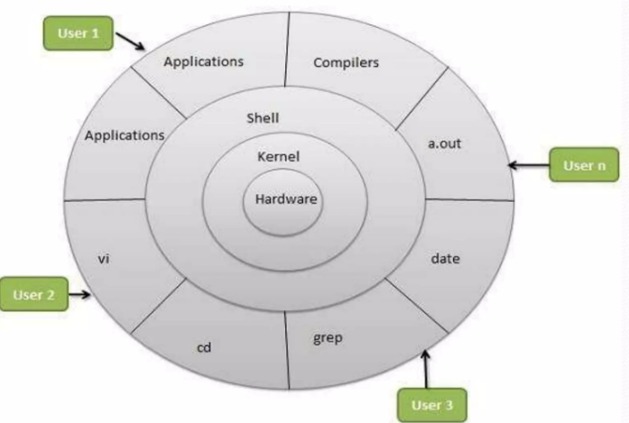
Architecture of Linux Operating System

Linux v/s Windows
◦ ﻿﻿Linux is freely available or online downloads, for windows companies have pay for their license.
◦ ﻿﻿Windows need up to date time to time, its updating process is slower than Linux.
◦ ﻿﻿Linux supports backward compatibility unlike to the windows.
◦ ﻿﻿Most of the software made on the windows are need to be licensed but in Linux all of them are freely available.

Part 1: Linux Basic and important commands:

Mobaxterm – setup for practice



MobaXterm Xserver with SSH, telnet, RDP, VNC and X11 - Home Edition

1. Basic Linux Commands

Navigation Commands:

cd <directory> – Change directory
cd .. to move back
cd <space> to move to parent directory
cd /

pwd – Show current directory
ls – List files

<command> <--help>

File & Directory Operations:

touch file.txt – Create an empty file
mkdir mydir – Create a directory
rm file.txt – Delete a file
rmdir mydir – Remove an empty directory
rm -rf mydir – Remove directory with content
Cp
Mv

Viewing & Editing Files:
cat file.txt – View file content
vi file.txt – Edit files
Search a text, toggle through the searched list of texts and then press n
Go to the top of the file: gg
Save edited file:escape ->wq! ->enter
Force close file (without saving): q!
Select all content in a file: VG
Delete all content in a file: ggVG -> d

grep "text to search" file.txt
ls -l | grep "example"
grep -v #to invert the selection
sed 's/old/new/' file.txt

2. Permissions & Ownership:

ls -l – Show file permissions
chmod 755 file.sh – Change file permissions

- r (read) = 4
- w (write) = 2
- x (execute) = 1
Permissions are granted by summing these values for each category. For example:
- rw- = reade (4) + write (2) = 6
- r-- = read (4) = 4
- rwx = read (4) + write (2) + execute (1) = 7

Permissions are set using a 3-digit number. Each digit represents the permissions for
owner, group, and others, in that order.

Chmod 764 filename

3. Process & System Monitoring:
ps aux – List all processes
top / htop – Monitor system resources
kill <PID> – Kill a process

Disk & Memory Usage:
df -h – Disk space usage
free -m – Memory usage

sed 's/test/nope/g' testFile.txt
ls --help
Up arrow

How to submit a job in background?
nohup sh ./test.sh &
o/p: [1] 2126

Here 2126 is the process id of that particular job which was submitted in background

Ps aux | grep 2126

Cronjob

Field | Allowed Values | Meaning
Minute | 0-59 | Minute of the hour
Hour | 0-23 | Hour of the day
Day of month | 1-31 | Day of the month
Month | 1-12 | Month of the year
Day of week | 0-7 | 0 or 7 = Sunday, 1 = Monday ... 6 = Saturday
Command | any shell command or script | What to run

crontab -e
1 * * * * sh /home/mobaxterm/cronjob_demo/fileCreator.sh

4.Basic Networking:
Networking means connecting computers so they can communicate and share data.
Example:
- Your laptop connected to WiFi
- Two Linux servers talking to each other
Check IP address of your linux machine
ifconfig

IP address

Interface name (eth0 / ens33 / enp0s3)

Test Network Connectivity
ping google.com

What it checks:
- Network reachable or not
- Packet loss
- Response time

Network Statistics
netstat -a

Check Port Connectivity
telnet google.com 80

If connected → port is open
If failed → port blocked
Download Data Using curl
curl google.com

Check Network Statistics
Ifconfig
Shows:
- RX packets
- TX packets
- Errors

Part 2: Shell Scripting Basics

1. Writing a Basic Shell Script:
Create a script:
Vi myscript.sh
Add the following content:
#!/bin/bash
echo "Hello, welcome to Linux!"Save and exit.

Give execute permission:
chmod +x myscript.sh

Run the script:
./myscript.sh

2. Variables & User Input Using Variables:
name="John"
echo "Hello, $name!"Reading User Input:
echo "Enter your name:"
read user_name
echo "Hello, $user_name!"

3. Conditional Statements & Loops If-Else Statement:

echo "Enter a number:"
read num
if [ $num -gt 10 ]; then
echo "Number is greater than 10"
else
echo "Number is 10 or less"
fi

For Loop:
for i in {1..5}; do
echo "Iteration $i"
done

while Loop:
count=1
while [ $count -le 5 ]; do
echo "Count: $count"
((count++))
done

Example program:
SOURCE_DIR="$HOME"
TIMESTAMP=$(date +"%Y%m%d_%H")
API_DIR="$SOURCE_DIR/LinuxTraining/API"
API_FILE="$API_DIR/AQI_file_$TIMESTAMP"
if [ -e "$API_FILE" ]; then echo 'file exist' else mkdir -p "$API_DIR" curl -X 'GET' 'https://api.data.gov.in/resource/3b01bcb8-0b14-4abf-b6f2-c1bfd384ba69?api-key=579b464db66ec23bdd0000010ce40eccaff74749502056f9014ce547&format=csv' -H 'accept: application/xml' -o "$API_FILE"
fi

